Quick guide of Network camera

Thank you very much for purchasing our product. If you have any questions or requests, please feel free to contact us.
We may update the contents of this manual according to the enhancement of product function, or improve and update the products or procedures described in this manual regularly. The updates will be added in the new version of manual without notice.

1. Network camera interface diagram
Port Type 1

CN1 | 1 | Orange | 485+
CN1 | 2 | Yellow | 485-
CN1 | 3 | Black | GND
CN1 | 4 | White | Alarm In+
CN1 | 5 | Black | GND
CN1 | 6 | Purple | Alarm Out+
CN2 | 1 | Red | DC IN 12V
CN2 | 2 | Yellow | Earth
CN2 | 3 | Black | GND
Port Type 2
Port Type 3

Power Port
1 | GND
2 | DC12V/1A
Net Port
7 | Alarm Out
6 | GND
5 | Alarm In
4 | RJ45-6 | RX-
3 | RJ45-3 | RX+
2 | RJ45-2 | TX-
1 | RJ45-1 | TX+
Port Type 4
※ Port Type 1: For fisheye panoramic camera HF - XD series, HF - TA1101 series, and general network camera GC - BC series, the GC - BL series, HF - CR1101 series products.
※ Port Type 2: For fisheye panoramic camera HF - QF3203 series, and Annular panoramic camera HM - CL series, HM - VS series and HM - DS series products.
※ Port Type 3: For fisheye panoramic camera HF - DB, HF - QF3001 series products.
※ Port Type 4: For fisheye camera HF - WA series products.

2. network camera connection
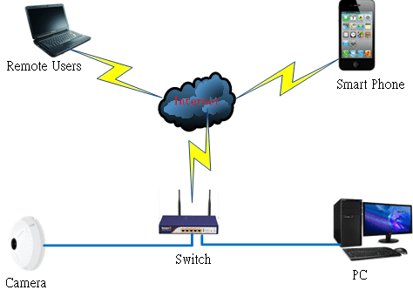
Network Connection Diagram (Switch mode)
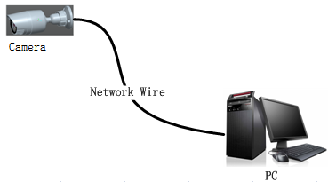
Network Connection Diagram (Direct mode)

3. quick access via ie browser
Step1: Check power and network is well connected when camera and PC is in the same LAN. Follow the steps to click【Start▶Control panel▶Network and Internet▶Network connection▶Local connection-mouse right button click▶property▶Internet protocol 4（TCP/IPv4）▶property】，Modify the IP address in the same segment as camera 192.168.1.※（Note: default IP address of camera is 192.168.1.123，※should be between 2~255，exclude 123）.
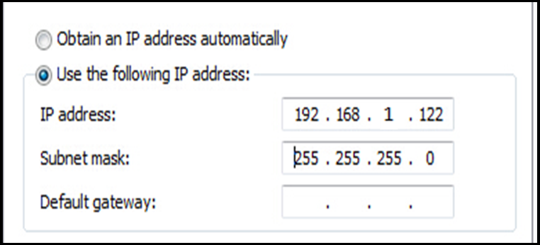
Step2:Install ActiveX controls and plug-in：Open IE browser, select “enable” or “prompt” for all the plug-ins in “ActiveX controls and plug-in” of Tools--Security--Custom level(C), set the security level to medium or low.
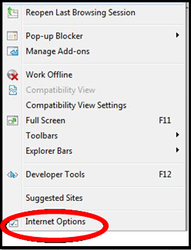
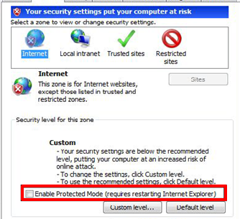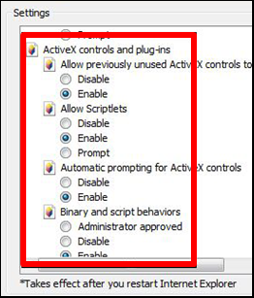
Step3: Enter the IP address of the camera in the address bar, press Enter. If it is the first visit, a ActiveX plug-in will pop up automatically. Click [Run] to install the control.
After the installation, Input username “admin” and password “123456”to login as the administrator.
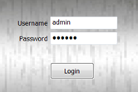

4. ACCESS via CLIENT SOFTWARE
Install client software (Panoramic Camera Software) from the CD attached. Then run the client software, it will search online device(s) automatically as below.
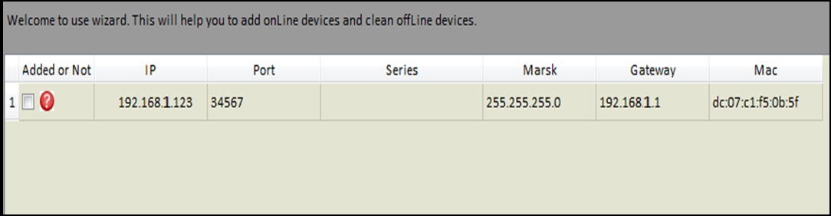
Check the box to select online device(s) that you want to view, and add it. When successfully added, you will view the live video of the camera that be added.

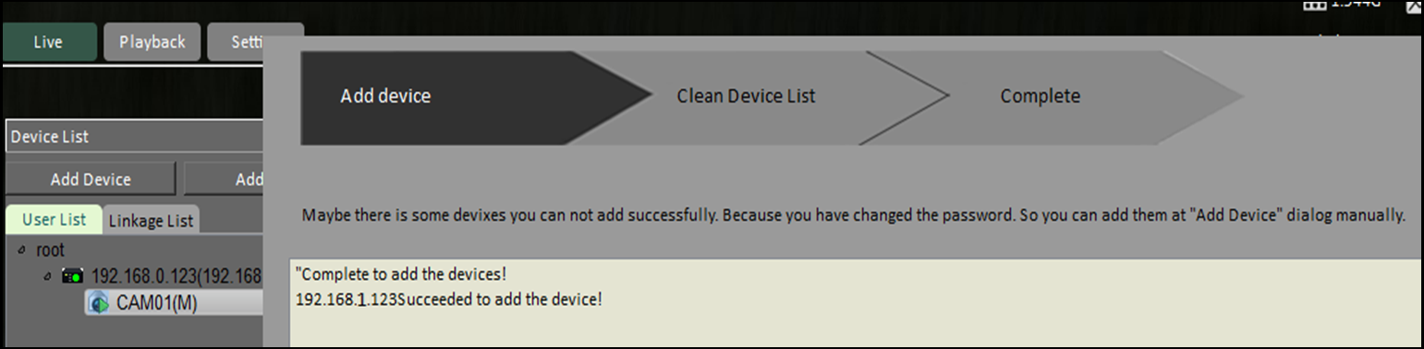

5. installation
1) Fisheye panoramic camera
HF-XD series HF-TA series
HF-DB series HF-WA series
Hole Site
Holder
HF-QF series
2 Annular panoramic camera
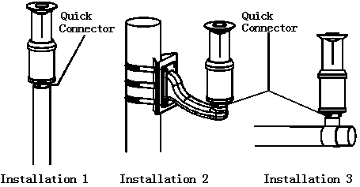
HM-CL&HM-VS series

HM-DS series

3 Other cameras installation
GC-BC series GC-BL series

